
SCHOOL OF ARCHITECTURE, COMPUTING & ENGINEERING
Module title:
Artificial Intelligence & Machine Vision
Module code:
CN7023
Assignment title:
AI & Machine Vision coursework
Module leader:
Dr Shaheen Khatoon
Student Name:
Martin Mwangi Mwarangu
Student Number:
2493079

Abstract:
Bird’s play a crucial role in the ecological system. Some are pollinators while others are predators with others being scavengers, they basically play a role in almost all facets of the circle of life. Over the last few decades though bird numbers have significantly reduced, and it is approximated that one out of every six birds have been lost. That adds up to the loss of 600 million breeding birds over 40 years, according to a 2021 study from the RSPB, BirdLife International and the Czech Society for Ornithology. Birds face a myriad of threats from climate change to encroachment by humans which has wreaked havoc on their habitats. Rapid and timely intervention is needed to prevent a major environmental catastrophe.
In this paper we shall look at how Artificial Intelligence (AI) and computer vision can be leveraged to help classify different bird species. The aim is to take an image of a bird and with a great degree of accuracy classify it according to its species. To do that this paper makes use of convolutional neural network trained on a large dataset of different bird images. All experiments in this paper were implemented on MatLab’s online environment.

Contents
Abstract: 2
Introduction 4
Creative and innovative approaches to the selected problem 5
Simulations 6
AlexNet 7
Training Validation and Testing 8
Training Options 9
Results Obtained 9
Critical Analysis of Results 11
Conclusions 14
References 14
MATLAB CERTIFICATIONS 15
‌ 17

Introduction
Increase in human population, poor farming practices and climate change are some of the many threats to bird populations around the world. This has led to a dwindling number of birds and without intervention it could easily lead to extinction. New developments in technology means we can make use of AI and computer vision to accurately classify bird species which will provide crucial data that can help formulate conservation strategies.
This paper therefore seeks to determine whether artificial intelligence and computer vision can be used to get a high degree of accuracy in species classification whilst also comparing which between a shallow network trained from scratch and a state-of-the art deep learning network fine-tuned for transfer learning (for this the paper makes use of the Alexnet network) gave the best performance (highest accuracy) on the given test data.
The paper will contain a brief explanation of what convolutional neural networks are and why they are the best for image classification as well as a snapshot of the experiments done on the dataset (dataset-preprocessing, network hyper-parameter tuning and deep learning network selection), the results and the conclusions drawn from those results based on the research questions stated above.

Creative and innovative approaches to the selected problem
.
Choice of neural network architecture: For image classification a CNN is chosen due to its ability to view images as data. A CNN takes pixels matrix of an input image, assign importance (learnable weights and biases) to various aspects/objects in the image, and be able to differentiate one from the other. CNN consists of several layers namely: input, convolution, max-pooling and a fully connected layer. There are several networks available with the choice ranging from pretrained networks (transfer learning) to creating your own network from scratch. This paper chooses to explore transfer learning with AlexNet being the network of choice. AlexNet is a deep learning CNN with 227 x 227 inputs 5 Convolutional layers Max pooling 3 fully-connected layers and ReLU nonlinearities.
Data preprocessing techniques: Image data tends to be unstructured and can come in various sizes and with different clarity. For AlexNet the input size required is 227 x 227 therefore the images in the dataset would need to be resized to match. The images also need to be placed in subfolders based on their classes to aid in classification. Depending on the images in the dataset other preprocessing techniques could include filtering, image-enhancement, dilation and erosion to improve clarity or Rotation, reflection etc to artificially increase the number of images the model can train on.
The bird image dataset that this paper explores contains 5712 images of birds split into 35 classes according to the species. Transfer learning is suitable for this dataset due to the high number of images and classes. AlexNet was chosen due to the network’s reasonable complexity and its ability to give a high degree of accuracy. The images in the dataset were of the size 224 x 224 meaning they needed to be resized to be accepted as inputs for AlexNet.
Network Training Options: The learning algorithm chosen was the stochastic gradient decent with momentum (SDGM). This is an algorithm that seeks to find the steepest descent during each iteration. The network made use of a learning rate of 0.001. Due to the size of the dataset four epoch were used in training with each epoch divided into 31 iterations and validation was done after every thirty iterations.

Simulations
The simulations on this dataset all took place in the matlab online environment. The bird dataset contains 5712 images split into 35 classes based on the bird species. The images have an input size of 224 x 224 and are taken from various angles at different times of the day in different environments. The images are all coloured no grayscale images are present in the dataset. The images are of reasonable clarity and therefore suitable for classification with no further preprocessing required. Below is a sample of the images included in the dataset.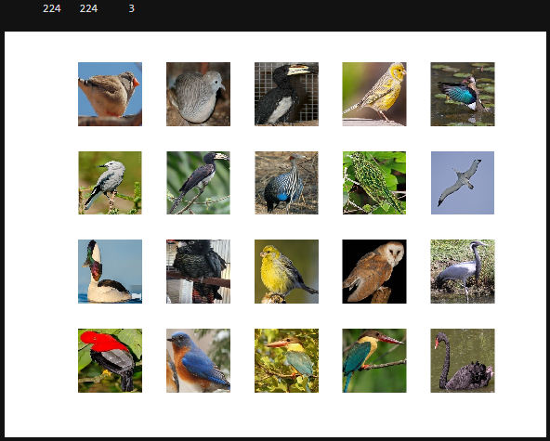
The images in the dataset are 224 pixels high by 224 pixels wide in size. AlexNet takes in an input of size 227 by 227 pixels therefore the images would require resizing to be suitable for use as inputs for the model. Since resizing 5712 images individually would take up far too much time an image datastore was created to manage the collection of images as one. To resize the images in the datastore an augmented image datastore was created and the input size for the images specified as shown in the image below.
No further preprocessing and image encoding was required as the images already met all other minimum requirements.

AlexNet
This paper made use of the AlexNet pretrained network to perform the classifications. AlexNet is a CNN used primarily for image classification it won the ImageNet classification challenge in 2012 making a breakthrough in the use of CNNs for image classification.
AlexNet has a simple enough network architecture as can be observed in the image below.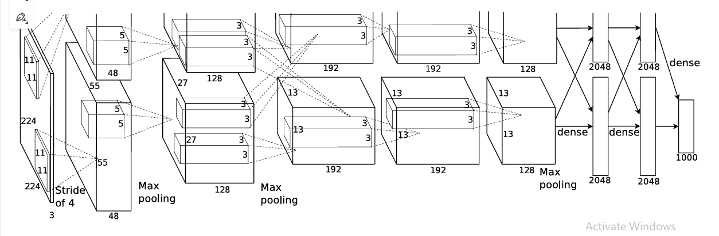
The network contains eight layers with weights; the first five are convolutional and the remaining three are fully-connected. The output of the last fully-connected layer is fed to a 1000-way softmax which produces a distribution over the 1000 class labels. The kernels of the second, fourth, and fifth convolutional layers are connected only to those kernel maps in the previous layer which reside on the same GPU. The kernels of the third convolutional layer are connected to all kernel maps in the second layer. The neurons in the fully-connected layers are connected to all neurons in the previous layer. Response-normalization layers follow the first and second convolutional layers. Max-pooling layers follow both response-normalization layers as well as the fifth convolutional layer. The ReLU non-linearity is applied to the output of every convolutional and fully-connected layer.
The first convolutional layer filters the 227×227×3 input image with 96 kernels of size 11×11×3 with a stride of 4 pixels (this is the distance between the receptive field centres of neighbouring neurons in a kernel map). The second convolutional layer takes as input the (response-normalized and pooled) output of the first convolutional layer and filters it with 256 kernels of size 5 × 5 × 48. The third, fourth, and fifth convolutional layers are connected to one another without any intervening pooling or normalization layers. The third convolutional layer has 384 kernels of size 3 × 3 × 256 connected to the (normalized, pooled) outputs of the second convolutional layer. The fourth convolutional layer has 384 kernels of size 3 × 3 × 192, and the fifth convolutional layer has 256 kernels of size 3 × 3 × 192. The fully-connected layers have 4096 neurons each.
Due to the fact that the dataset discussed in this paper doesn’t have 1000 class labels as output I made use of matlab’s deep network designer to change the final fully connected layer to match the output of 35 classes present in the dataset. The figures below show the network design showing the input layer and the fully-connected layer with 35 input classes
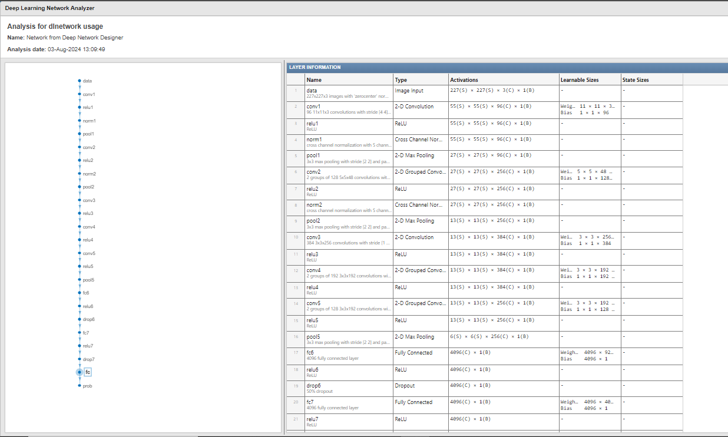
Image showing the 227 by 227 by 3 input layer
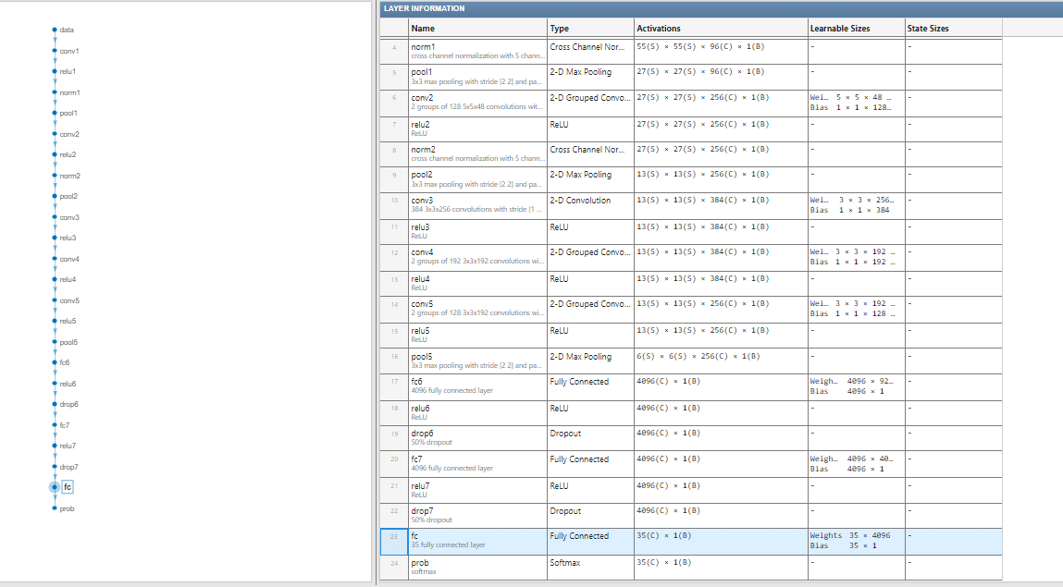
Image showing the output layer with 35 classes.

Training Validation and Testing
The image datastore was split into three with one set going to training the model another going to validation and finally one going to testing. The split was random on a 70-10-20 basis with seventy percent going to training the model ten percent going to validation and twenty percent going to testing.

Training Options
The learning algorithm chosen was the stochastic gradient decent with momentum (SDGM). This is an algorithm that seeks to find the steepest descent during each iteration. The process decreases the time it takes to search large data sets and determine local minima immensely. It is suitable for image classification problems because it generalizes better than other optimizers for example adam. The model was trained with an initial learning rate of 0.001 which produced an optimal training time whilst still giving optimal results (94.41% accuracy) and four epochs other simulations were done with a different number of epochs and the results are discussed in the sections below. Validation was done at every thirtieth iteration. Due to how closely related some of the species in the dataset are the images were reshuffled at the beginning of each epoch this was done for the model to learn from different patterns during each epoch to help prevent the model from overfitting.
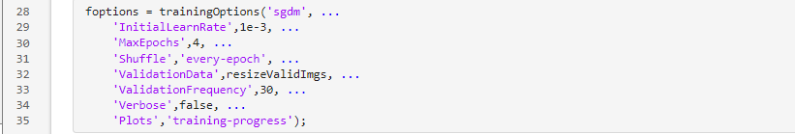

Results Obtained

The model performed best with a learning rate of 0.001, on four epochs. There were one hundred and twenty-four total iterations with each epoch having thirty-one iterations. The model took six minutes and twenty-five seconds to train achieving a final validation accuracy of ninety-three six four percent (93.64%) and an accuracy of ninety four point four one percent (94.41%) when run through the testing data as shown below.

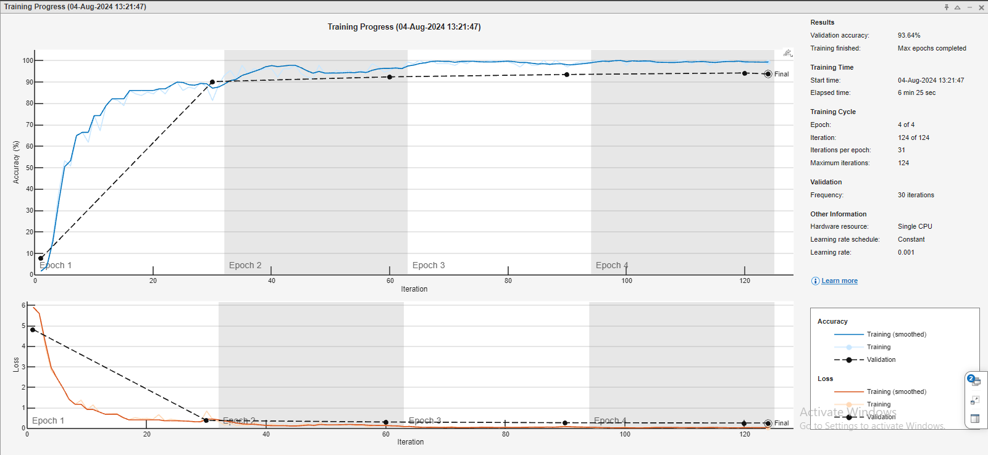
The accuracy of the model rises sharply during the first epoch with the accuracy rising from ten to ninety percent in the first thirty iterations. The accuracy rate then stabilizes in the next three epochs with a final validation accuracy of ninety-three-point six four percent being achieved. The loss curve also falls sharply towards zero in the first epoch before eventually stabilizing around the zero mark for the rest of the epochs.
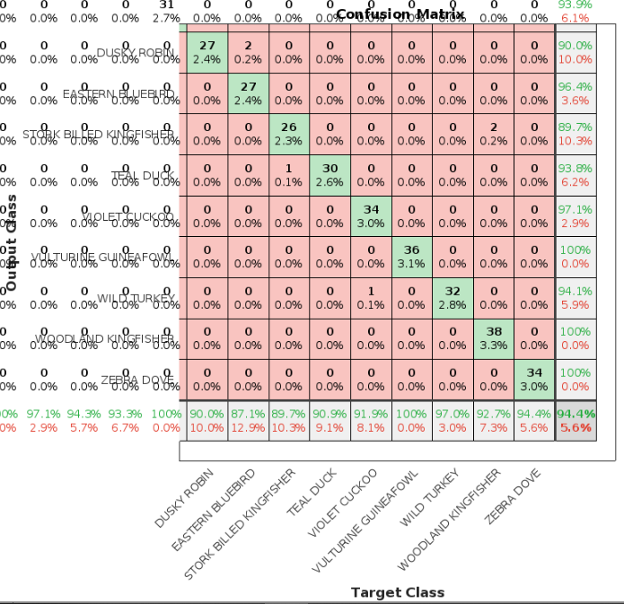
The confusion matrix above is a snapshot of the overall confusion matrix showing the last seven classes. The matrix shows the final accuracy of 94.41%. The matrix also shows the a few of the bird species the model struggles to identify. From this matrix we can deduce that the model struggles with the stork billed kingfisher falsely classifying two woodland kingfishers in this category (false positive) whilst also falsely classifying a stork billed king fishers in the teal duck class (false negative) overall it has an 89.7% accuracy while attempting to classify stork billed kingfishers. The model performs best when classifying the vulturine guineafowl with !00% of the birds classified correctly (no false positives or negatives).

Critical Analysis of Results
The model made use of transfer learning which is a deep-learning technique that makes use of an already pretrained network that is then optimized to fit the dataset. The images in the dataset were placed in subfolders based on species. The classes each had between 140 -200 images. The dataset was then split into training (70%) validation (10%) and testing (20%). AlexNet was used to train the model with stochastic gradient decent model with momentum (SGDM) used as the optimizer. A learning rate of 0.001 with four epoch was used and an accuracy of 94.41% on the test data was achieved. To improve the performance of the model several techniques can be considered these techniques include but are not limited to decreasing the learning rate from 0.001. implementing a mini batch size based on the images in the dataset and performing augmentation to give the model more images to learn on.
Based on some of this metrics other simulations were run with a mini batch size specified at twenty and a learning rate reduced to 0.0001. This simulation improved the accuracy of the test data slightly to 95.02 percent as shown in the image below.

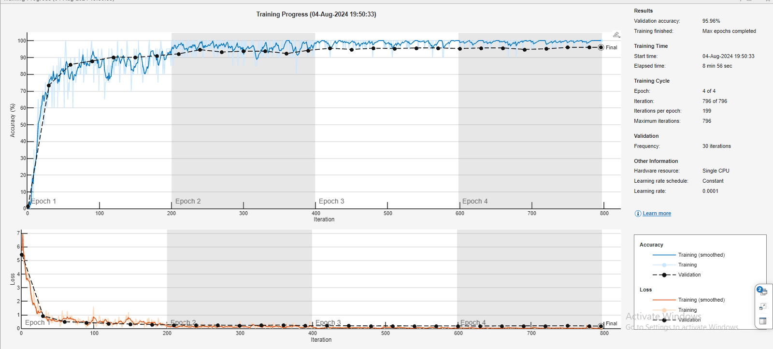
The accuracy of the model rises sharply during the first epoch with the accuracy rising from zero to seventy five percent in the first thirty iterations. The accuracy then rises steadily towards the ninety percent mark as we trend towards the end of the first epoch. The accuracy rate then stabilizes in the next three epochs with a final validation accuracy of ninety five point nine six percent being achieved. The loss curve also falls sharply towards zero in the first epoch before eventually stabilizing around the zero mark for the rest of the epochs. The time taken for the model to run was eight minutes fifty six seconds.
This shows that the suggested changes lead to a bump in the accuracy, but they also lead to an increase in training time by more than two minutes. While on the test data did increase it wasn’t by a high enough degree to justify the increase in training time. This paper finds that the initial accuracy of 94.41% was high enough and attempts to improve on it only led to very slight improvements and sacrifices elsewhere for example in run-time which are probably not worth it. Another method is increasing the epochs this again rises the final validation accuracy to 96.34% and the test data accuracy to 95.28 % but this comes at an increase of the training time as well which moves to thirteen minutes almost doubling the previous training time the trade-off between accuracy and training time is again not worth it since we only get a slight increase in accuracy.
A shallow network was also explored as an option. The network had three convolutional layers, two max pooling layers, Relu layer for non-linearity, one fully connected layer, a softmax layer and a classification layer. This was done in order to compare the difference in performance between a shallow self-trained network and transfer learning with the following results found.
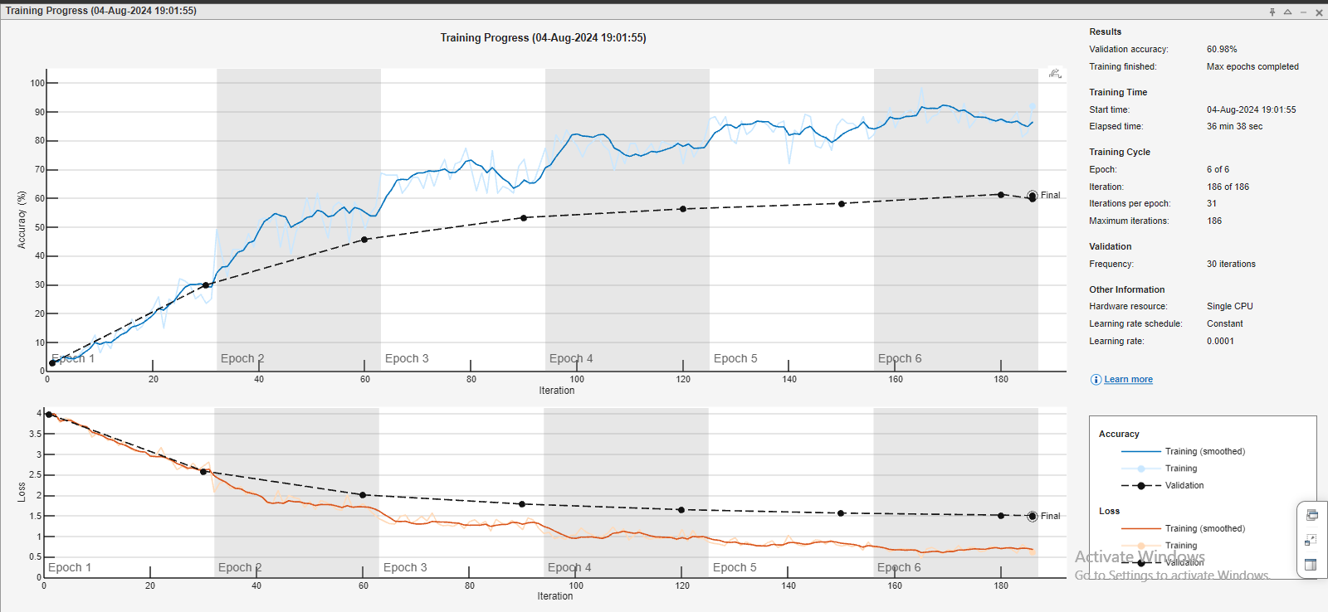
The model doesn’t generalize well on the validation data with a poor final validation accuracy of 60.98%. The model performs even worse on the test data having a final test accuracy of 57.78% as shown below
This model takes a long time to train with a training time of thirty-six minutes thirty-eight seconds. It overfits the training data and the loss is far too high. Attempts made to mitigate the overfitting such as implementing early stopping, increasing the learning rate and implementing a mini batch size did little to improve the results.

Conclusions
In conclusion this paper sought to find whether computer vision could be used to accurately identify different species of birds given different images. The images chosen were real world images of the birds taken in different context as would be found in nature. Some of the species were closely related with very few distinguishing features while others are very divergent despite these challenges this paper has found that computer vision can classify the birds according to their species with a high degree of accuracy as the model discussed in this paper took in over five thousand images spread across thirty-five different bird species and returned an accuracy of 94.41%. Therefore, the ability of computer vision to reliably classify birds based on images will prove crucial in the conservation efforts by providing crucial data to help monitor bird numbers. This paper also sought to find what would work best for the bird classification problem between a network created from scratch and transfer learning using a pre-trained model (AlexNet). The findings were that AlexNet gave the best accuracy with a 94.41% accuracy on test data compared to a 57.78% accuracy for the network created from scratch. This could be due to the complexity of the image dataset with the images being taken from different angles in different environments at different times. The features of some species are also closely related with very little to differentiate them. Thus, a deep network with many layers was needed to fully learn the features from the data and provide satisfactory results.

References
Gerry (2023). BIRDS 525 SPECIES- IMAGE CLASSIFICATION. [online] Kaggle.com. Available at: https://www.kaggle.com/datasets/gpiosenka/100-bird-species/data [Accessed 10 Aug. 2024].
‌Cornell.edu. (2022). Stochastic gradient descent - Cornell University Computational Optimization Open Textbook - Optimization Wiki. [online] Available at: https://optimization.cbe.cornell.edu/index.php?title=Stochastic_gradient_descent#:~:text=SGD%20is%20an%20algorithm%20that [Accessed 10 Aug. 2024].
Zhang, X. (2022). Can AI save the birds? - British Ornithologists’ Union. [online] British Ornithologists’ Union. Available at: https://bou.org.uk/blog-zhang-can-ai-save-birds/ [Accessed 10 Aug. 2024].
Manager, A.S.S., Research, T., Manager, A.S.D.S. and Publications (n.d.). Global Research and Analytics Firm. [online] www.aranca.com. Available at: https://www.aranca.com/knowledge-library/articles/ip-research/can-ai-help-save-birds.
RSPB (2023). RSPB. [online] www.rspb.org.uk. Available at: https://www.rspb.org.uk/birds-and-wildlife/issues-facing-birds.
cassiebreviu (2024). Classify endangered bird species with Custom Vision - Training. [online] Microsoft.com. Available at: https://learn.microsoft.com/en-us/training/modules/cv-classify-bird-species/ [Accessed 10 Aug. 2024].
news.cornell.edu. (n.d.). AI analyzes bird sightings to help conserve species | Cornell Chronicle. [online] Available at: https://news.cornell.edu/stories/2023/10/ai-analyzes-bird-sightings-help-conserve-species.
‌ Krizhevsky, A., Sutskever, I. and Hinton, G.E. (2012). ImageNet Classification with Deep Convolutional Neural Networks. Communications of the ACM, 60(6), pp.84–90. doi:https://doi.org/10.1145/3065386.

MATLAB CERTIFICATIONS




‌

‌

‌

‌

‌

